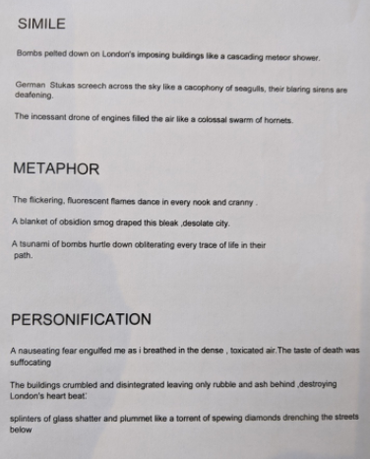
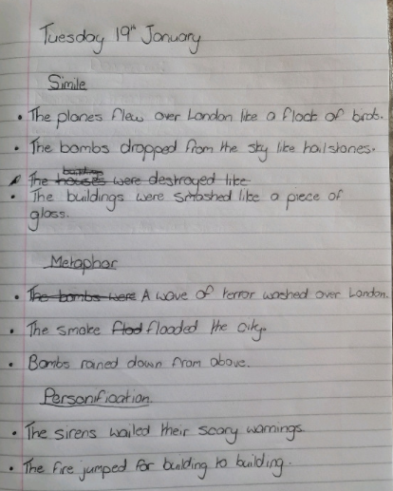

Similes
- Dark memories lingered like smoke after a fire.
- Smoke engulfed the city like a blanket.
- The planes above filled the sky like a swam of
locus.
- The sirens screeched like a crying child.

Metaphor

- A wave of terror washes over the city.
- The mechanical birds soar above the
doomed city.
- The blanket of smoke engulfed the city.
- Bombs rain down from above.

Personification
- The siren screamed its angry call.
- The destructive bomb landed a deadly blow.
- Planes above whispered their deadly intent.
- Tall, angry flames leapt from one house to
the next, excited with their ability to spread.
- Endless clouds of smoke stared down at
the frantic firefighters.
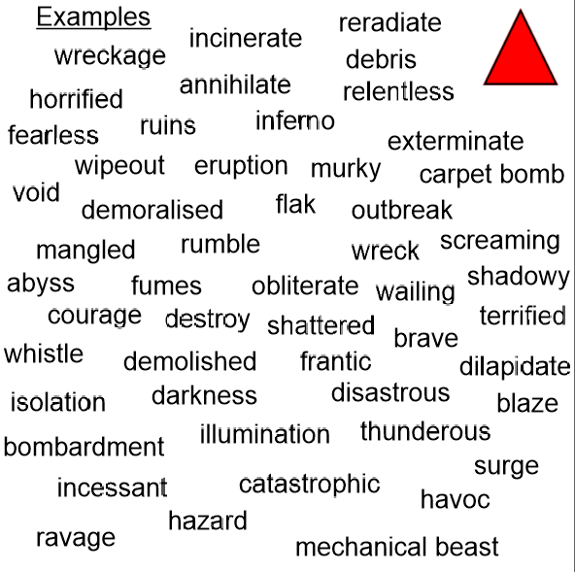

The buildings were engulfed with a layer of smoke.
The flames danced through the ruins of the tower.

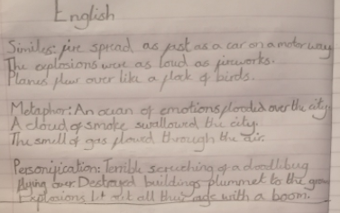

The bombs kiss the ground releasing their deadly breathe.

