Need to get the Kids off the Sofa?
We Can Help!
Come and Join us at the Workington Zebras where we have Rugby Sessions for School Reception to Yr 6!

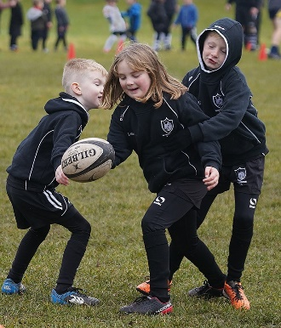
Physical & Mental exercise, Make Lifelong Friends, Challenging, Build self-esteem, Improve Social Skills.

Learn the RFU Core Values: - Teamwork, Respect, Enjoyment, Discipline & Sportsmanship.

Ellis Sport Ground @ 10am every Sunday.
Contact Andrew Branthwaite 07725236661

