Calculations Policy – Ashfield Junior School
This policy is broken down into addition and subtraction, and multiplication and division. Beginning each policy, an overview of the different models and images used can be found that can support the teaching of the different concepts.
Each operation is broken down into skills. Each skill has a section showing the different models and images that could be used to teach the concept. A glossary can be found to ensure consistency of mathematical language throughout each year group.

Tens Frame (within 10) (Year 3 & if required, Year 4)
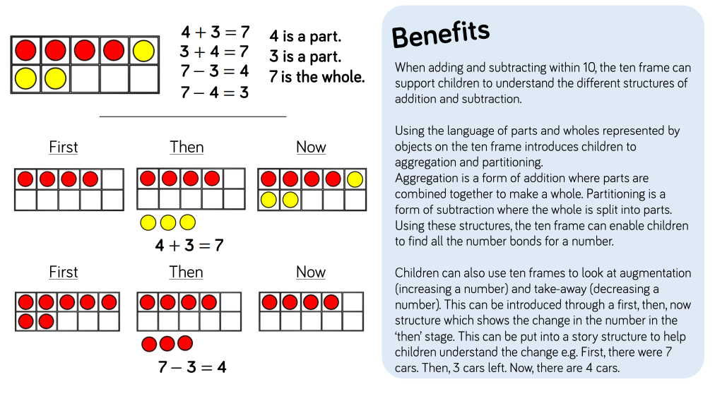

Tens Frame (within 20) (Year 3 & if required, Year 4)
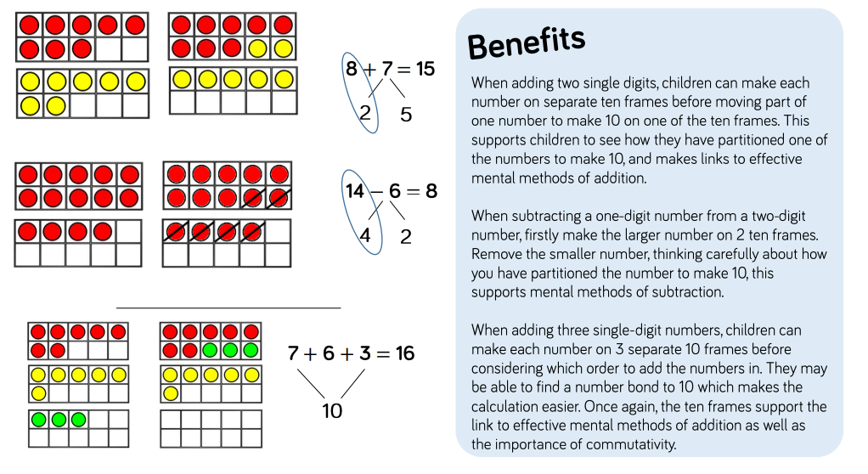

Number Tracks (Year 3 & Year 4)

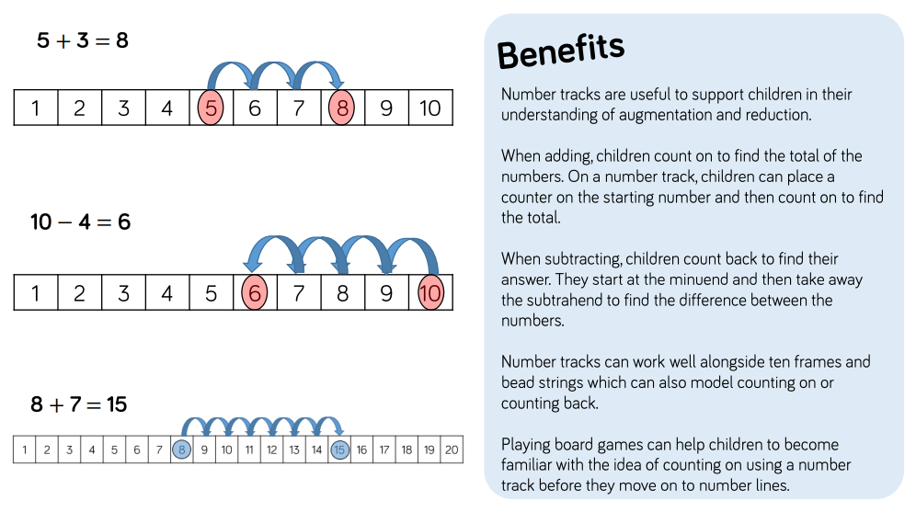

Number Shapes (Year 3 & Year 4, optional use in Year 5 & Year 6)

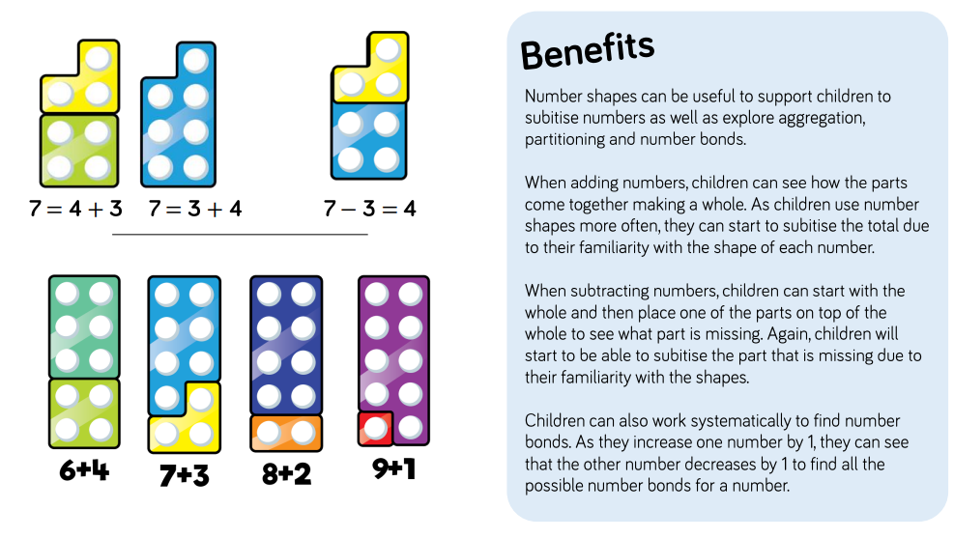

Bead Strings or Cubes (Year 3 & if required, Year 4-Year 6)

Bead Strings
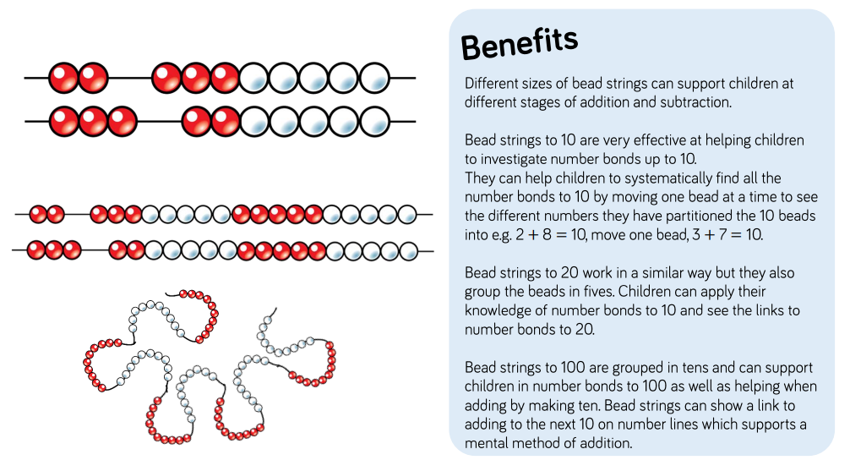

Cubes

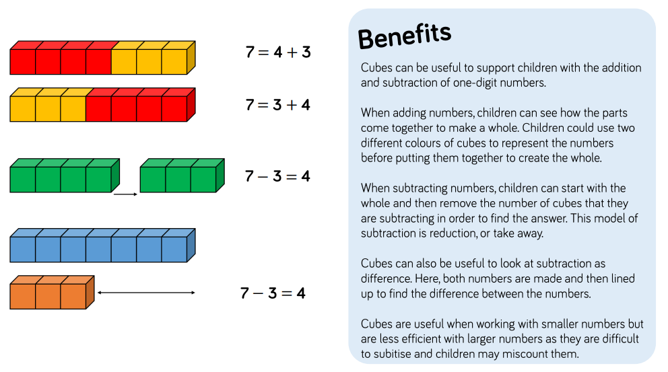

Number Lines (labelled) (Year 3-Year 6)

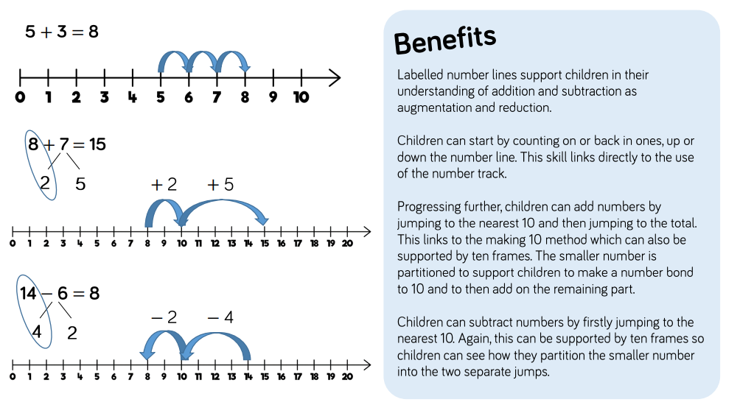
Number Lines (blank) (Year 4 – Year 6)
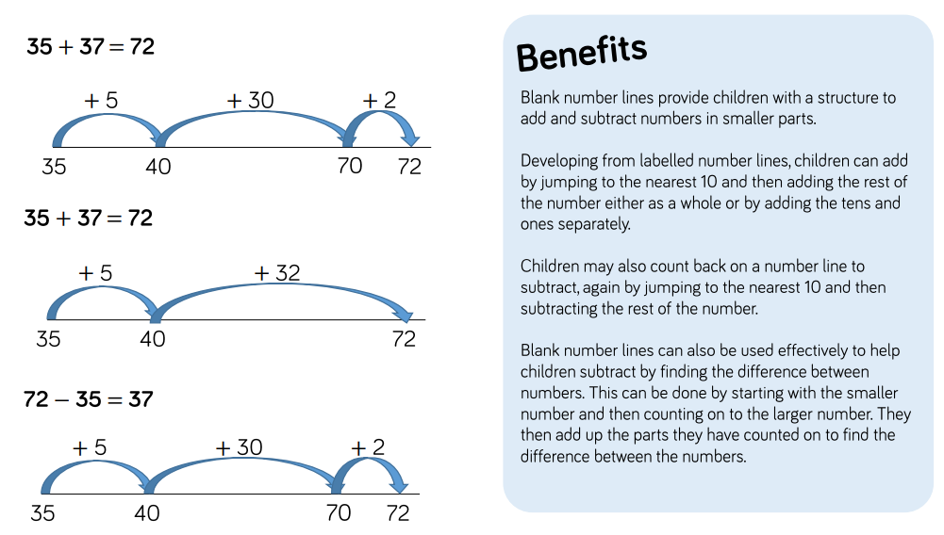

Part-Whole Model (Year 3-Year 6)

Bar Model (Single) (Year 3 -Year 6)

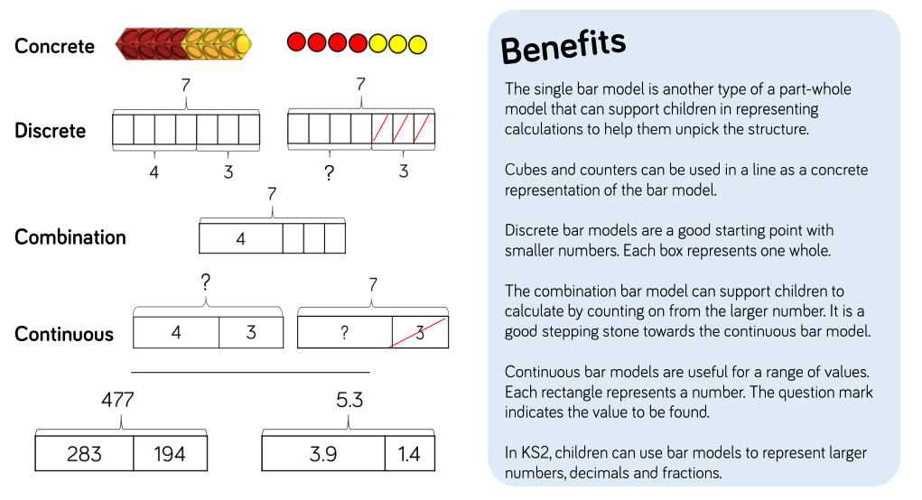

Bar Model Multiple (Year 5 -Year 6)

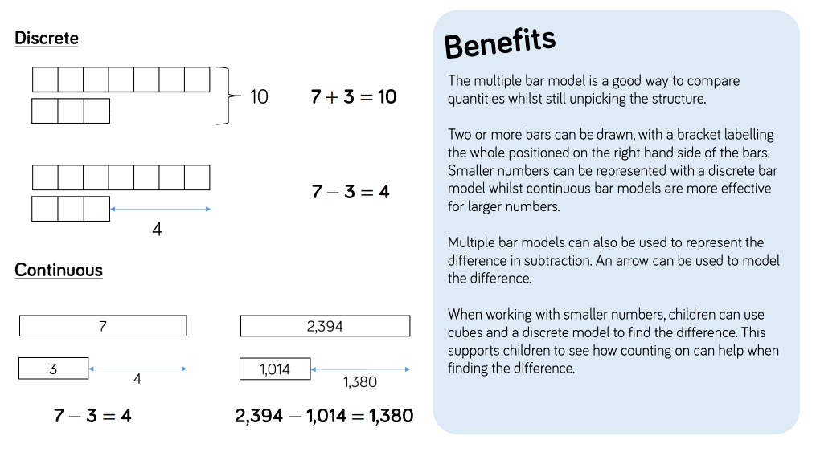
Base Ten/Dienes (addition) (Year 3-Year 5 & if required, Year 6)

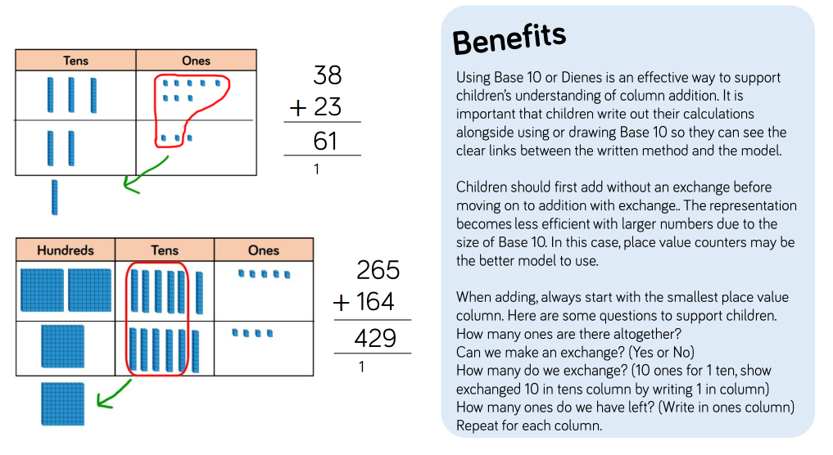

Base Ten/Dienes (subtraction) (Year 3-Year 5 & if required, Year 6)
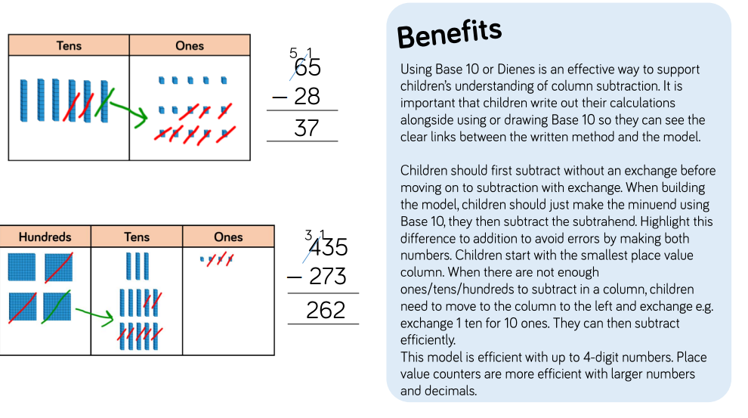
Place Value Counters (addition) (Year 3 -Year 6)

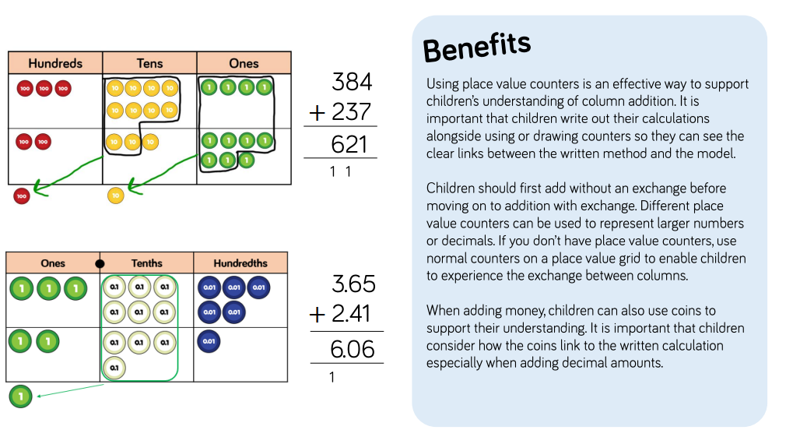

Place Value Counters (subtraction) (Year 3 -Year 6)

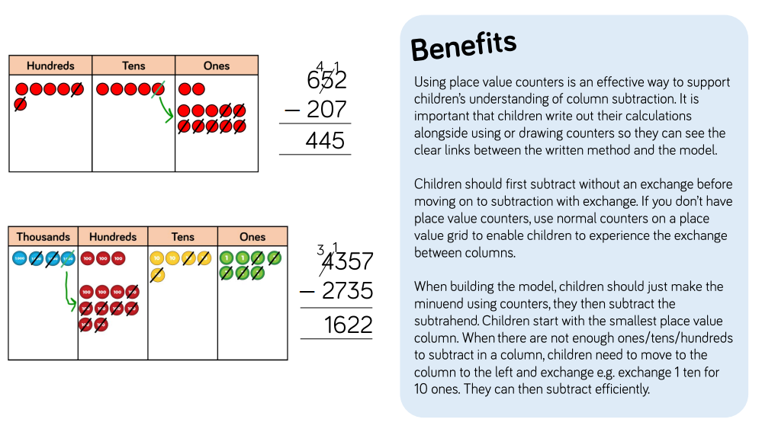
Formal Written Methods of Addition

Year 3:
Up to 3-digit by 1-digit numbers, then up to 3-digit by 2-digit numbers

Year 4:
Add numbers with up to 4 digits

Year 5/6:
Add numbers with more than 4 digits (Y6: numbers up to 6 digits)

Year 5:

Add numbers with up to 3 decimal places

Year 3:

Subtract 1 and 2-digit numbers to 100

Year 3/4:

Subtract numbers with up to 3 digits

Year 4:

Subtract numbers with up to 4 digits

Year 5/6:

Subtract numbers with more than 4 digits (Y6: up to 6 digits)

Year 5:

Subtract with up to 3 decimal places

